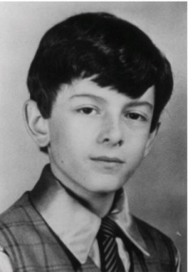 Christopher Millard – “The Four Diamonds”

ND MiniTHON 2024
Important Last Minute Details for Dancers and Parents
- Dancers please report to your assigned room on Saturday, February 17th between 8:00 and 8:15 am.
Blue Team – Room 206
Green Team – Room 203
Orange Team – Room 201
Purple Team – Room 3
Red Team – Room 10
Yellow Team – Room 2
- All morale boxes should be dropped off in ROOM 108 not 101 Saturday morning.

- Dancers, remember to bring your own water cup (Yeti, Stanley, etc.). We will have water and Gatorade available during the 24 hours.

- Dancers – remember to have parents drop off medication with medical form to the Medical Room (Library Commons) at 8:00 am.

- Parents – please remember to pick up medication at the conclusion of our MINITHON.

- Dancers, please be sure to bring all toiletry (toothbrush, toothpaste, etc.) items along with sweatpants/sweatshirts, extra socks, sneakers….).

- Parents are welcome to stay for the kick off of the event as well as visit anytime during the 24 hours. PLEASE remember that security will not allow any outside food or drinks into the gym.

- Dancers, remember that we are pushing for all of you to raise what you can for the cause!!! Donations can be taken on line or you can certainly bring in donations (be sure your name is on the envelope) Saturday or Sunday of the event.

GET REST!!
DRINK PLENTY OF WATER!!

Thank you ND Students for standing for those who cannot!!!!

“When cancer is cured we will dance for joy; until then we will dance for LIFE!”

FTK

