Physics Test Ch 3 Prep-Questions

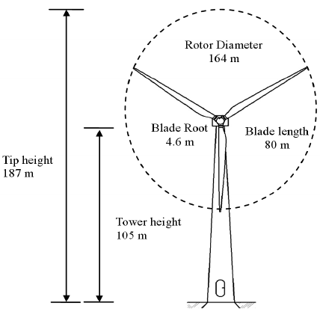 P
An electric generator on a wind farm uses a three-bladed propeller mounted on a pylon at a height of 105 m, as shown in the figure. The width of the pylon is very narrow, and the length of each propeller blade is 80 m (total center to tip 82m). A tip of the propeller breaks off just when the propeller is vertical. The fragment flies off horizontally, falls, and strikes the ground at point P with negligible air resistance. Just before the fragment broke off, the propeller was turning uniformly, taking 1.2 s for each rotation. How far is point P from the base of the pylon?

Given: r = 82m t rot = 1.2s h = 187m g = - a = 9.8m/s²
Find: distance from base to P = d_{P}
Equ: time in air d = ½ g t² Circle: C = 2 π r = π d
v = $\frac{d}{t}$ or d = P = v t

S & S: t = 6.18s C = 515m v = 429 m/s P = (429m/s)(6.18s) = 2653 m
Ans: P = 2653 m

Refer to the figure below. If a projectile is fired from t = 0s from the edge of a cliff, distance of 0m, with initial velocities components of v_{ox} = 27 m/s and
v_{oy} = 138 m/s. The time of projectile flight is 59 s with no air resistance. What is the horizontal distance D? How high above the cliff is the projectile before it begins to fall to point P? Find the magnitude and direction of V_{o}.

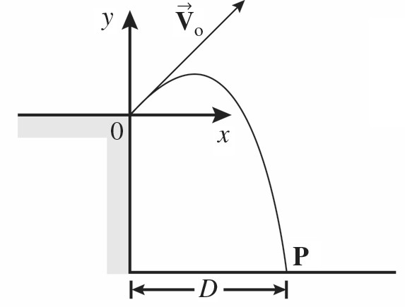

Distance D = vt = (27 m/s)(59s) = ??? m

Height above cliff = h_{max}
t = v/a = (138 m/s)/(9.8m/s2) = ??? s
x = h_{max} = ½ a t² = ½(9.8) (14.1)² = ??? m

V_{o}² = v_{x}² + v_{y}² → V_{o} = $\sqrt{{27}^{2}+{138}^{2}}$ = ??? m/s
Cos θ = 27/141 → θ = ??? or Tan θ = 138/27 → θ = ???

Distance D = vt = (27 m/s)(59s) = 1593 m

Height above cliff = h_{max}
t = v/a = (138 m/s)/(9.8m/s²) = 14.1 s
x = h_{max} = ½ a t² = ½(9.8) 14.1² = 974 m

V_{o}² = v_{x}² + v_{y}² → V_{o} = $\sqrt{{27}^{2}+{138}^{2}}$ = 141 m/s at 11º E of N
Cos θ = 27/141 → θ = 79º N of E

As shown in the figure, a projectile is fired at time t = 0 s, from point 0 at the upper edge of a cliff, with initial velocity components of v_{ox} = 30 m/s and v_{oy} = 300 m/s The projectile rises and then falls into the sea at point P. The time of flight of the projectile is 75 s and air resistance is negligible. At this location, g = 9.8 m/s2. What is the horizontal distance D?

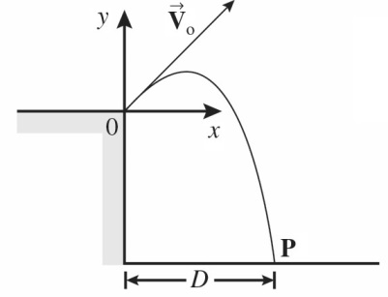

D = vt = (30 m/s)(75s) = ?? m
D = 2250 m

A boy kicks a football from ground level with an initial velocity of 17 m/s at an angle of 40° above the horizontal. What is the horizontal distance to the point where the football hits the ground if we neglect air resistance?

R = v_{o}² sin 2θ Range Equation for level ground
g

R = 29 m

