Measurement Lab

Lab partner’s name(s)

Mr. Wakeman

Class, Period, Date

Introduction – (Name of writer if you are writing 1 report per group.)

The purpose of this lab is to measure the distance in paper, mass of pennies and water, times of a falling object, and volume of a room. A further purpose in this lab is to learn to use lab equipment, record data, calculate error, and write a formal lab report.

Materials – (Name)

Micrometer
Vernier caliper
Textbook paper
Meter sticks – tape measure
Electronic scales (0.01 g)
Stop watch (Cell Phone)
Rubber ball

Etc.

Methods – (Name)

Use a micrometer and a vernier caliper to measure the thickness of one piece and 100 pieces of paper. Measurements should be done in 3 different places on the paper and are reported in the write-up as individual numbers and averages. The average is reported in meters with the conversion factor 1 meter = 39.37 inches or 1 inch = 0.0254 meters.
Use a balance or scale to measure each penny’s weight. Record the penny’s year and mass, . . . etc.

Data – (Name)

Tables with data (numbers and units). Report all numbers with averages and error estimates ( The only number which is not an average of numbers is the volume of the room.)
This lab should have error estimates which are your best guess of how accurate the measurements are to the average. Report the numbers like this: volume of room = 100 ± 5 m³

US Pennies (10)
Year | Mass (g)
1960 | 3.14
1964 | 3.20
1964 D | 3.11
1990 | 2.52
Ave | 2.83 ± 0.1 g
etc.
Example: Distance – meters (m)

Mass – grams (g)

Time – seconds (s)

Volume – meters
cubed(m³)

Graph of pennies weights:

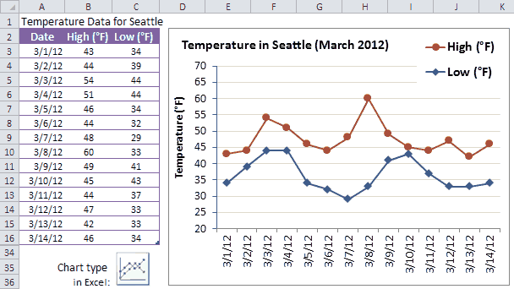

Results / Discussion / Analysis – (Name)

What does the data mean? What can be learned from the data/experiment? Is your hypothesis correct? If not why not? Were there any mistakes or errors in the data or lab?

This section is the most important part of the lab and should be completed with as much detail as possible.

What are the sources of error? What could you do differently to improve the lab or data? What could you calculate from the data? Density? Acceleration due to gravity? Are you measuring mass or weight and what is the difference?

Conclusion – (Name)

Single paragraph – What you did in the lab.
Are your hypotheses true or false?
Explain what happened or what was true or false.

Parts of the Lab Report

1) Title – Name(s), Date, Class, Period (sm)

2) Introduction – What you will test. (sm)

3) Materials – List of every piece of equipment used (sm)

4) Methods – How did you make your measurements (med)

5) Data – Tables of numbers. All the numbers generated. Graphs (Big)

6) Results – Heart of the lab. Discuss hypotheses – Were you right?
Observations, Concerns, Errors, Improvements, . . . etc. (Big)

7) Conclusion - What you did in the lab. (sm)
8) Organize Report – Big Job, put report together in above format. (Big)
9) Print Out Report – Big Job, Make report look (Big)

Rubric for Measurement Lab

Lab neatly typed, one sided – 10 pts
All seven parts complete – 10 pts
Hypotheses included - 10 pts
Graph of pennies - 10 pts
Well written Results/Discussion- 10 pts
Numbers calculated correctly- 10 pts
Actual ball drop times - 10 pts
Why pennies are bimodal - 10 pts
Actual mass of water 1 ml = ?? - 10 pts
Error correction included - 10 pts

